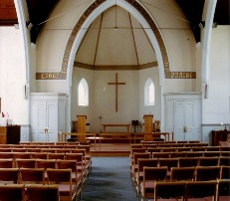
THE AVENUE
STANFORD AVENUE
METHODIST CHURCH,
BRIGHTON
August – September 2022

Minimum Donation 50p

THE AVENUE
Minister: Revd Dan Woodhouse Tel: 01273 508704
E-mail: revdanwoodhouse@gmail.com
Church Office Answer Phone: Tel: 01273 554141
E-mail: stanfordmethodist@btconnect.com
Assistant to Minister: Major Connie Croly: Tel: 01273 875376
Editor: Martyn Coblenz: Tel: 07724 605610

Calling all Ladies from 18 - 118!!

I hope you will have heard about our ladies night fundraising event
on Friday 14th October. We will be having exclusive access to a show of good quality high street and boutique fashion ladies clothes.
(The models may look surprisingly familiar!) and afterwards, if
anything takes your fancy, there will be an opportunity for you
to buy them at greatly reduced prices! You will be able to try the
clothes on and all major credit cards are accepted.

We do hope you will be able to come to this event, as there
promises to be something for everyone, whatever our age and shape!

It will be held in the Church Hall and tickets cost £6 to include a drink on entry, and snacks will be available.

Tickets can be bought in advance from Liz on 01273 430508 or email:
ticketsforstanford@gmail.com

We would love to see you all at this event…and why not bring a friend?

The Fundraising Team

SYD BECK

Introduction

It is comforting to stand here where Dad did on several occasions delivering a reading and I’m honoured to do this for our Dad.
I remember when I was about 5 or 6, Derek’s mates would come round to play and always call me ‘Young Syd’.

Although I didn’t particularly appreciate the comparison at the time, as I’m sure you’ll agree you don’t really want to be likened to your dad at that age and although I didn’t realize when I was 6, as you get older, you do develop an appreciation and respect for all that your parents have achieved, as well as the considerable responsibilities they undertook on your behalf.

Dad was born on 21st June 1931-the Longest Day of the Year
Good job it was the longest day .This must have been a sort of premonition of all he would go on to pack into his very full life.

Family

Dad married Mum 29th September 1956 in this very church and were married for nearly 60 years.
Although they had to wait a while for Grandchildren like buses, 8 came along in as many years between 1991 and 1999.

It was great that Dad was able to see Great Grandson, Rory, who bought a smile to his face which can be seen through photographs of the 4 generations that were taken in 2020.

Derek, Hazel & I have all been married here, and some of you may remember Mum & Dad renewing their vows on the occasion of their Golden Wedding Anniversary in 2006. Many of the Grandchildren were christened here… I think you might by now follow the immense connection we’ve had with this Church, and this connection was instigated by our Dad.

Home

From birth Dad, lived at 9 Ladysmith Road, Brighton and
21 Hollingdean Terrace - where Nan and Grandad lived until they passed away in 1986…
Dad experienced tragedy in May 1942, when his brother Dennis at the age of 3 years 9 months died in a house fire at his home.
Dad, 11 at the time, tried to rescue Dennis and received an NSPCC Diploma of Honour for bravery which was presented to him by the Mayor of Brighton. This episode must have had such a significant effect on such a young boy.
Just after they got married, Mum and Dad moved to 83 Balsdean Road, Woodingdean which despite a relatively young age Dad designed and arranged the construction of himself.
In 1961 they moved to 165 Hollingdean Terrace -, also known affectionately by the Grandchildren as the Batcave and they stayed there happily for the duration of their lives.
The Grandkids also referred to Dad’s last car as the Bat mobile. Let us not forget the early cars Dad had. Grandad Gardiner had given Dad a Ford Popular. Which actually wasn’t that popular certainly with Derek when he was being collected from school.as He was so embarrassed that he insisted that Dad park up the road rather than directly outside the gates in Balfour Road! The indicators didn’t always work properly, so Dad had to stick his hand out the window to demonstrate which way he was turning.
After a couple other Fords, Dad then acquired his pride and joy. The Cortina MK 3 which he bought from Chris Catlin a BHA player at the time. This car has been lovingly restored to former glories by Dave.

In the mid 1960’s with the help of a couple of local builder mates and neighbours the garage was erected at the bottom of the garden. It still stands as only of a couple on garages that remain in the Terrace!
Who can forget the Bathroom Project that took forever- during a ‘bathroom ‘ discussion ,the word futile was mentioned to which someone then said, ‘a bit like your Dad Rob, a few tiles every couple of weeks!’

Academic achievements

Dad went to school at Moulsecoomb Primary then to Fawcett School on London Road.

Dad always encouraged us to get examination qualifications or ‘tickets’ as he referred to them.
Looking through the many Electrical and other City & Guilds Certificates he achieved, the remarks in the reports included words such as keen, conscientious, capable, clear thinker, retentive memory, neat and a hard worker. This was Dad’s work ethic throughout, and these were great qualities to set for us, his family.

Dad was still studying hard at the time the three of us were born.

Work

On Leaving school at 16, Sayers Electrical was his first employer. As apprentice electrician Dad could have died in an incident when was up to his waist in water in a basement and carrying out "first fix wiring" when he got an electric shock which threw him across the room. He was very lucky to have survived!

The obligatory 2 years national service at that time saw dad joining the Army in the Royal Signals Corps in 1953 - and was posted to Egypt. Unfortunately, he had return early due to have Gall stones removed.
There is fantastic picture from that time with Dad looking like something out of ‘It Aint Half Hot Mum’ which of course may have been a forerunner to Dad treading the boards in later years.

Dad joined the General Post Office at North Street, Brighton on 7th March 1955, subsequently moving to Churchill Square sometime in the early 70’s when it became BT. Dad certainly didn’t appreciate the management phrases that started to be introduced at that time and the less said about Buzby the better!

Some of you may recall that when we eventually had a phone installed at home, it was a payphone…how embarrassing for us as teenagers to make calls to mates and the pips sounding then having to put money in the slot

Dad retired in 1991 after 36 years with the same employer at the age of 60 - unheard of in today’s world, but an indicator of his stability and loyalty.

Travels & Holidays

Early 1960’s our family went on a caravan holiday to the Isle of Wight with John, Norma and Keith.
In 1969 we revisited the island which happened to coincide at the same time as the very first Rock Festival there, with 150,000 hippies attending and music legends such as Jimi Hendrix and the Who appearing. I can’t imagine that Dad booked the holiday with the festival in mind but who knows?
In 1974 Dad won a trip in a BT raffle to go to New York. Instead, Dad managed to negotiate to swap the trip to go on a cruise round the Norwegian fjords. More Mum and Dads style.
There was a Pilgrimage with several friends from the Church to the once in a decade Passion Play in Oberammergau in 1990.
In 1996 together with, Barbara and Colin and John and Norma they went to Canada and visited Eddie and other cousins.
In 2012, Bermuda to visit Rich and Maria. There is a photo of Dad in Bermuda shorts similar to the one when he was in the Army!!

We had many holidays during the 70’s at Minehead and Ilfracombe with both the Harris clan and Nan and Grandad Gardiner. What fantastic times we had and many happy memories.

What we didn’t realise till recently is that Dad was also on the Committee and became Chairman of the Brighton Area Caravan club for 6 or 7 years in the late 1980’s early 90’s.Through which we holidayed as kids, at West Bay and latterly the caravans were relocated to the Freshwater Beach site near Burton Bradstock in Dorset which they absolutely adored and must have gone to that site every year for I would have thought at least 15 years. It was their love of the area and Freshwater site which prompted Elaine and me to acquire a static at the same site in 2019 to be able to continue the tradition of happy, family holidays

Sport

Dad loved his sport and not just the participation, but also with the administrative functions that every voluntary association requires by sitting on or Chairing committees as well as being involved with the preparations for the events such as being part of the working party to prepare the pitch for matches at Glynde. Saturdays between April and September were always taken up with Cricket which Mum long suffered.

He was a keen Footballer; It’s rumoured that he played the day I was born!!
He played hockey during his Army days and after hanging up his cricket boots, Dad joined the Bowls club.
He loved his Table Tennis-playing for NALGO with Stuart if I recall correctly.
Derek remembered that in 1966 when we were on holiday in Pontins at Selsey and Dad won the Pontins Table Tennis Championship that week. The Chinese Army National Table Tennis team were on tour and staying at the site, Dad managed to arrange practising and playing with them. What an experience!
Regarding Dads cricketing prowess - he was Wicketkeeper for BBOB’s and a stable mid order’ batsman. He couldn’t be described as swashbuckling in his style but could be considered steady and reliable.
Although at the time I didn’t really appreciate the significance, but what an experience being able to play in the same team with your Dad and brother not only at Glynde for BBOBS, but subsequently for Denton at the beginning of the 1980’s. One memorable match being in 1981 when Des took most of the wickets that day and Dad and I were in partnership at the crease at the end, hitting the winning runs. Great memories.

Dad coached the BB Colts-between 1971-74. Des’s mates, I referred to earlier (John and Melv) are likely to have been under the tutorship of Dads coaching. I certainly was. Des decided to play for an alternative team!!

Music

Dad was an accomplished pianist - and could tinkle the ivories. How on earth a piano was accommodated in the dining room at 165 one wonders!
Through the local library Dad joined a record club in the late 60’s –
2 records every fortnight on a Friday. .Dad had wide ranging musical tastes from classical -Vivaldi 4 Seasons through to the Monkees, Andy Williams/Perry Como and The Carpenters.
Comedy vinyl’s were listened to such as Bob Newhart and Stan Freberg.
Flanders and Swann was a favourite with such tracks as The Hippopotamus and Transport of Delight - which together with Geoff Starks they performed at some gala occasion held downstairs.
He could of course recite the tale of The Green Eye of the Yellow God’ without any prompt.
Les Miserable was Mum and Dads favourite musical with the cherished track Bring Him Home as we’ve just heard at the crematorium.
In July 1984- all of us went to see Neil Diamond in concert at Earls Court. This event will remain forever my abiding memory of Dad. I can see the image now of him with arms aloft, on his feet, swaying with the crowd, and singing along to Song Sung Blue and Sweet Caroline. How delightful that all these years later that Sweet Caroline was voted the song for the Platinum Jubilee, and it is just a little sad that being Royalists having grown up with the Queen they weren’t here for the recent celebrations.

Crackling Rosie though was his favourite.

Stanford Avenue Church

This Church played a significant part of Dad and Mums lives and ours as children in our formative years.
Uncle John met Dad through the Youth Club here when he was 12 and so has known Dad for over 70 years. (Jill/Sylvia) Latterly we carried on the tradition through Rendezvous marvellously run by Sylvia.
16th Boys Brigade - Arthur Jackson being Captain at the time and Harry, Johns Dad, being Lieutenant.
Circuit Steward - We will remember Dad filling the Communion glasses when the congregations flocked here.
In 1990-Modernisation of Church - Clerk of works for about a year -Just neatly following on from retirement and just before Grandchildren arriving.

Dad undertook a similar project for Derek and Lynn as interior clerk of works on the building of Half Smock - between May and December 2004

Both Mum and Dad were actively involved with the Stanford Avenue Players, the amateur dramatic society here.
Hazel shared a stage with both Mum and Dad in several productions, which is a list far too vast to mention
Hazel recalled that Dad was the very first Pantomime Dame in the production of Mother Goose and latterly when he dressed up as Mrs Gribble in Wild Goose Chase, his Mum didn’t speak to him for a week!!

February 2004 Busy Body was his-Final Production in the capacity of Director - Hung up his ‘Drama Boots’ and put the lid on the grease paint for the final time.

Geoff recently described Dad as a fundamental cornerstone to the various committees on which he sat

In Summary

There have been so many happy memories that I have not been able to include but I must mention Christmas times always being special occasions. Again with the Beck and Harris families and Grandparents and of course when the Grandchildren arrived many a joyful time was had. No doubt we will regale the stories over a sandwich and a drink.

We have been really blessed as a family with such great parents

As well as Dads work ethic he held other values dear to his heart-family, faith, sense of duty, dignity, responsibility, and commitment

He did have had a great sense of humour, and I can picture him now watching Morecambe and Wise throwing his head back, pushing his hand through his hair, then lurching forward slapping his thighs and really laughing hysterically

I saw a quote recently which I thought was quite apt in describing Dad -
"Success comes in a lot of ways, but it doesn't come with money, and it doesn't come with fame. It comes from having a meaning in your life, doing what you love and being passionate about what you do. That's having a life of success. When you have the ability to do what you love, love what you do and have the ability to impact people. That's having a life of success. That's what having a life of meaning is."
What a packed and fulfilling life Dad has led but of course without Mum by his side this would have not been possible and since Mum passed away in 2016 Dad really lost his zest for life. Who wouldn’t after being with someone for over 60 years?
The occasion of Dads 90th celebrations last year was such a memorable day with all the family in attendance and the photos really do reflect what a joyous occasion it was. We know that Mum would have loved it.
Finally, to use the cricket analogy 90 a very good innings and a ‘good knock’ as Dad would say.

So, Dad, at last you are where you have wanted to be, with Mum, and I’m sure both of you are looking over us now and wanting us all to remember all the happy and joyful memories that we’ve all had.

All my love and respect to you Dad...your ’Young Syd’

The Architect & The Carpenter -
A Tribute Read by James

On Behalf Of

Although I will be saying some words today it’s important for you all to know I am speaking on behalf of all Syd’s Grandchildren who love him ever so much.

The Architect & The Carpenter

If our Grandmother was the Architect who envisioned this family that we call home, then our Grandfather was the Carpenter who helped bring her idea to life.
You see, Grandad had the temperament and the intelligence of a carpenter calmly ensuring that his wife, Faye, Our Nan, had all the tools and materials she needed to make the project real.
He inspected and learned each part of the project, his children and his grandchildren intricately

Learning the Project

He got to know each of these components, these pieces, these people that sit among you today…he got to know them thoroughly.
And although he sometimes didn’t show it or, in some instances couldn’t fully communicate it…he knew each of us deeply.
He got to learn our passions, our interests and sometimes offering direction as to who we should be, who we could be, or who we might be.
Usually, this was done over long discussions at the breakfast table, singing wartime songs to us whilst we were in the bath, over the pruning and preening in the garden, or during very long car journeys.

In fact, it has only recently occurred to me that he drove that slowly just to spend extra time with us….although I am sure many Brighton motorists would have a different opinion!

Rest

Carpenters working on a decades-long project need their rest and my gosh…did our Grandad like to rest.
I am not sure I can blame him, trying to keep up with an Architect who had such restless feet must have been ever so tiring.
It’s no wonder that he structured his professional retirement around his family, his sports, this Church, the amdrams, 3 staple meals a day, and an eye-watering amount of washing up!
Honestly, I don’t think anyone here today really appreciates the amount of washing up that man truly did!
Although he was a talented and precise mathematician, I would argue that even he couldn’t calculate the amount of time he spent with his hands in that basin

The Master Carpenter’s Lessons

Master carpenters impart lessons and wisdom to their apprentices
In an effort to immortalise some of his legacy I have collected some of these from his grandchildren and I want to share with you just a few today
1. Grandad taught me how to check in on people and make sure they are happy. Usually done best by entering a room, throwing ones hands up in the air and asking is “everybooddyyy happpyyyy” It was hard not to be happy after that.

2. Grandad taught me the importance of giving someone warm feeling inside through celebrating their achievements and telling them how proud you are of them
3. Grandad taught me what responsibility means and how to be responsible for yourself and importantly for others. He also taught me how to be accountable for my own words and my own actions.

4. Finally. Grandad taught me that no matter what the mood, the weather, or the situation…Neil Diamond is a fundamental part of life’s ongoing playlist.

Many people here today would argue that last one is the most important… and I would likely agree with you

The Architect’s Life and The Carpenter’s Balance

Carpenters, like our Grandad, are rarely the glitz or the glam of important projects
Although we remember Nan bringing the energy, the love and the life to the work of our collective we must never forget the wit, the drama and the music that Grandad so often brought.
Above all else, our Grandad brought a modesty and a balance to the work which is as important in any successful undertaking.

It’s Love…

In a rare move into the spotlight, many years after his time treading the boards, Grandad imparted some words to us during one of Nan’s birthday lunches on a sunny, warm, Brighton afternoon
I am going to close with those words for you now. I only hope I can do them justice
More poignantly, I hope we all can do them justice as we march forward with this Architect and this Carpenter, this Great Man, this Great Grandad in our hearts
“It’s love….it is love that has brought us all here today. And it is love that will keep
us together as we go on”

Martyn – These Two eulogies were taken from Syd Beck’s Memorial service at the Church by kind permission from the family.

"Saint Richard's in the Wilderness".

I came across this Church just recently while researching online and as it happens is in fact the most northerly cathedral in the province of Himachal Pradesh, India and is wholly functioning and restored from when I had first viewed St Richard's at the end of the 1970's.

We'd been travelling on the roads, railways, buses and trucks for months when we turned back again in the direction of the Himalayas, primarily to search out the major Tibetan refugee settlements said to be at the former British Hill station of Dharmsala.
When the British administered India, the heat in the summer proved too much for most European born people, hence summer settlements to continue the processes of government were established in the cooler mountain areas and many have become well known such as Simla and Dharmsala. We arrived at Dharmsala on the 10th July 1977. The monsoon just behind us by only a few days. Contrary to common European traveller perception at the time , the main Tibetan settlements were higher into the mountains above Dharmsala where there had been a further smaller Hill station which remains known as "Macleod Gunj". Our first attempt to reach Macleod by the small road and footpath from Dharmsala that afternoon was foiled by heavy rain, and we were driven back to Dharmsala as the small road we were on simply had become a river.
The next day we started out again, this time on the local bus and reached Macleod by midday. We went in search of the Tibetan library which we never found, though we did find the palace abode of the Dalai Lama guarded in those days by only one visible Indian soldier in ceremonial dress armed with a rifle. We then continued on a wider path out of Macleod and before long virtually stumbled upon a wholly English style church surrounded by an extensive graveyard overgrown by numerous plants, grasses and bushes. Many of the stones were Victorian and they generally had English names and were of many young persons who had passed. In the Victorian times and into the 20th century there were not many effective treatments or cures for the ailments of the East and even malaria could often prove fatal.
The church was obviously abandoned , there were tiles off the roof and actual gaping holes in the roof. We were then assailed by the sudden heavy rains of the early monsoon, and we hurriedly approached the door of the great church that we might find shelter, but to no avail , though the door opened about twelve inches , it was held by mighty chains and a huge old, rusted padlock. Pressed against theses doors to obtain some respite from the downpour, the view inside was eerie. The interior was damaged but intact, the pews were mostly but not all standing and secured, the pulpit and organ were recognisable though covered in parts by debris from the vaulted ceiling of the church. Rain was pouring through the holes in the roof on to the marble floor of the aisle and making a cacophonous din. The rain had not yet subsided, and we sought shelter by nearby trees until it did and then resumed our discoveries among the grave stones and searched for other information on the bare church noticeboard crumbling and appearing literally as did the church at that time in its final days . I had expected the church to have fallen down or been demolished quite soon for safety's sake and certainly that I would never see it again. So my wonder and astonishment when I found that "St Richards in the wilderness" was still with us! Wholly restored and functioning as a Christian church at the little-known former hill station of Macleod Gunj in the Himalayas above Dharmsala where it had previously appeared to me as an eerie ancient Christian relic originally constructed in the Victorian era , crumbling and largely forgotten.

Christopher Paul.

Martyn – Thanks for this Christopher.

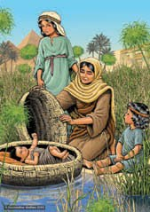
The coffee morning for AFC on the 9th July raised £452, this amazing total was reached by the magnificent support of Stanford Avenue and Friends. I was so worried that it would not make very much because I had not advertised enough, but I need not have as everyone rallied round making cakes, serving teas and coffees, selling crafts, Bric a Brac, plants, books and jam as well as helping me to set up and spending/giving money! Loads of morale support. Oh, and special thanks to Ivor and Pam who arrived outside on the bus, they made such an effort to support AFC and it’s really appreciated. Thank you all!!! What a great crowd of people you are. A real Can Do! attitude.

When I was a student nurse (a long time ago!) training to be a children’s nurse working on the Trevor Mann Baby unit at the Sussex County, I had a rather special assignment. A member of staff found a bag in a telephone box outside the hospital, inside the bag was a new-born baby girl. The baby was bought up to the baby unit, and the Sister in Charge decided that I would escort the baby to the Children’s Hospital, the Royal Alex. I felt very important being trusted with this special task and remember walking out to the ambulance with my cloak wrapped round me looking very smart. The baby only hours old, looked so large in comparison to the premature babies I had been caring for and I remember had a beautiful head of dark hair. I proudly held the special bundle in my arms and climbed in to the ambulance holding her close, as I did the press had gathered and were asking questions, thankfully the door was shut and off we went! She was given a name by the person who found her, I have never forgotten that name and cannot share it with you other than it was a biblical name. Many years have passed, and I often think about her and what happened to her and her mother. I hope she has a happy life and found her mum again; I hope they are both okay.
I thought about the Bible and a story which had a comparison and Moses in the Bullrushes came to mind. Exodus 2:3 “But when she could hide him no longer, she got a pyrus basket and coated it with tar and pitch. She placed the child in it and put it among the reeds along the bank of the Nile” Two mothers’ different times each trying to save their children hoping for a better life for them. Heart-breaking decisions. Maybe with support that mum could have kept her baby perhaps with the help of an organisation like AFC

Dates for the diary

Gaynor will collect any boxes /donations during August on Sundays at Stanford Avenue. A special worship service to support AFC, Help them Shine will be on Sunday 18th September 2022 (Hopefully with a Speaker, but it will be great anyway!).

Gaynor Paul for AFC

Martyn – All of this is great news & fantastic results. A big thank you from all the Church Family.

CHURCH FAMILY NEWS

We continue to pray for June Lawson, Nadine & Gary Pugh, Ann Collins, John Pollard (Vic & Margaret’s Son), Sylvia & Ray Smith, Debbie Johnson, Jean Griffin, Doug Butler, Liz Wakeling & Amy Codling (Leaders of Scouts & Girls’ Brigade), Phil Codling, Ian Codling, Maureen Knell, Sheila Whyte, Jean & Geoff Starks, Wynn Funnell, Gill & Shirley Challen and Margaret Trengenza, Pam & Ivor Challis, the family of Brenda Nurcombe.

As always, please let me know if you want me to remove any names, add to them or update us with news of any of the above.
We of course continue to pray for our Circuit staff as they minister to us – namely – Revd’s Andy Lowe, Deborah Cornish, Dan Woodhouse, Heather Leake Date, Major Connie Croly, Sue Harrington, and all our Lay Workers and Local Preachers.

MEDITATION & MUSIC.

The date of the next Music & Meditation meeting are :-
17th Aug 2-30 – 6-00 & 21st Sep 2-30 – 16-00 pm in the Fellowship Room.

Best wishes Sylvia Lord.

FUNDRAISING UPDATE.

We will be hosting a Flower Pot Festival on 24th & 25th September, and we would love individuals and groups to be involved.

With our children and young people being very aware of climate change, we are inviting you to join us for our very first Flower Pot sculpture exhibition. Many plastic flower pots go to land fill because there are very few places that recycle them, so why not make them into something that gives a smile!

This is going to be a fun community event where we are hoping to raise a smile or two and also the perfect opportunity to use your empty plastic flower pots. Turn them into a dog, a face or something bigger and better! We suggest you google Settle Flower Pot Festival for some imaginative ideas.

We will be holding a workshop on 17th September from 10 o’clock to 2 o’clock when anyone who wants to make a “sculpture” is very welcome to come and have a go. We have lots of flower pots so no excuses!

There will be a nominal fee of £2 per sculpture and no limit to the number you create and exhibit.

The festival will be open on Saturday 24th September from 11 o’clock to
3 o’clock and Sunday 25th from 12 o’clock until 2 o’clock.

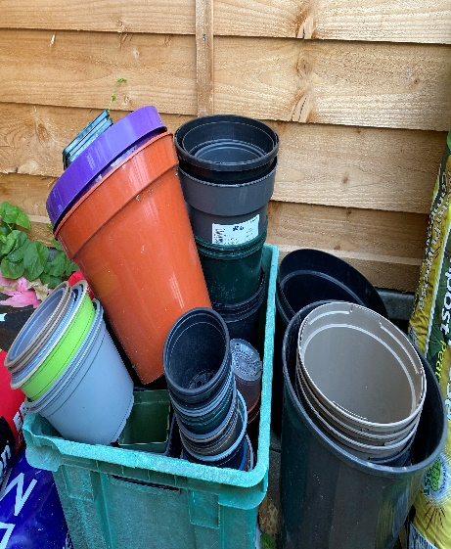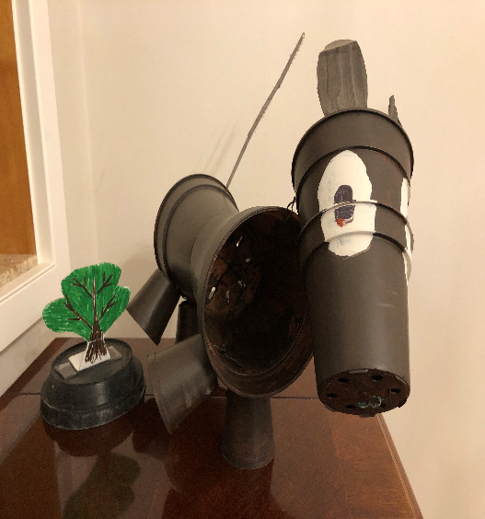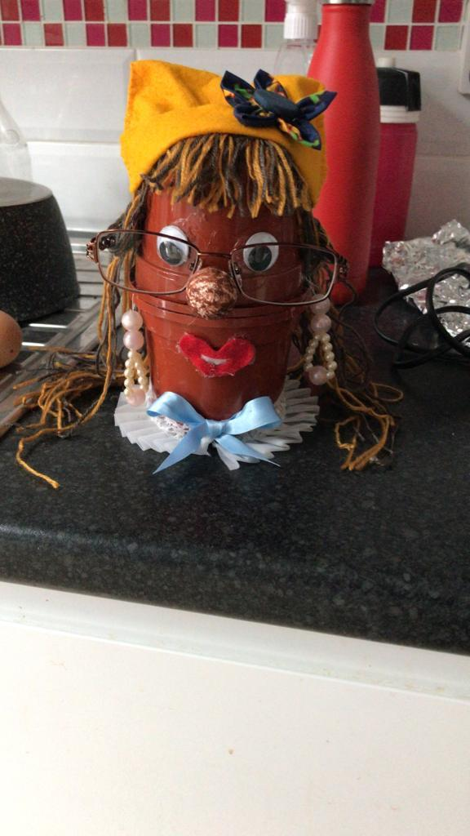

Let us know if you have any questions! We hope to hear from you soon. Email Lis and Lorna, lissyloucrafts@yahoo.co.uk or call any member of the fund-raising team.

Don’t forget we are also planning our Christmas Fair 26th November with details of what we need coming soon.

Many thanks from your Fund-Raising team.

WHO AM I?

I was born in Redhill

I have lived in 7 Houses

My favourite meal is Lamb Chops, Peas & Mashed Potato

My favourite place is Cornwall

My Hobbies include Watching movies & Astronomy

My favourite films are Where Eagles Dare & Zulu

I like watching & playing Snooker

I have always had an ambition to be an Astronaut

I like watching Costume dramas

I have a pet hate for T.V. Soaps

LAST DAY for OCTOBER-NOVEMBER 2022 magazine contributions will be FRIDAY 23rd OCTOBER.

You will be able to send contributions via E-Mail: stanfordmethodist@btconnect.com, or, by post to Stanford Avenue Church with ‘For Magazine’ on the front of the envelope.

CONTRIBUTIONS NEEDED.
Please, please, please send me your items for the Church Magazine. Especially as Wynn had finished her item on being a Red/Bluecoat. If I do not receive items, it may not be worth producing. I’m sure that some of you have some very interesting stories or items that others would be interested in.
Please send them to the stanfordmethodist@btconnect.com or drop them through the Church letterbox.

Dates for your diary.

17th September Flower Pot Festival Workshop
24th/25th September Flower Pot Festival
25th September Harvest Festival
14th October Fashion Show for the Ladies
1st November All Saints Service 19-30
26th November Christmas Fair

PAUSE FOR THOUGHT
In my last Pause for Thought we looked forward to the Queen’s Platinum Jubilee. I recorded most of the events and watched them at my leisure. It was wonderful seeing the crowds cheering the Royal Family as they appeared on the Palace Balcony several times.
On the Sunday of the weekend I had the privilege of leading a Jubilee Service. We had three of the Queen’s favourite hymns and two of the readings from the Thanksgiving Service, finishing the service with two verses of the National Anthem.
The first reading was from 1 Chronicles:16
A Song of Praise.
Give thanks to the Lord, proclaim his greatness.
Sing praise to the Lord.
Tell the wonderful things he has done.
Be glad that we belong to him.

Those words make me think of a hymn:
Give thanks with a grateful heart
Give thanks to the Holy one
Give thanks because He’s given
Jesus Christ, His Son
Give Thanks
(MP 170)

The second reading in the Jubilee service was
Philippians 4: 4-7

Don’t worry about anything, but in all your prayers ask God for what you need, always asking Him with a thankful heart. And God’s peace, which is far beyond human understanding will keep your hearts and mind safe in union with Christ Jesus. So, GIVE THANKS, DON’T WORRY, PRAY WITH A THOUGHTFUL HEART.

Not always easy to do but when we do, no matter what our circumstances our hearts and souls will be lifted.

Lastly, I was reading a leaflet about prayer. One reading suggested was Mathew 7; 7-12.
ASK, SEEK, KNOCK.
For everyone who asks, receives; the one who seeks, finds; and to the one who knocks, the door will be opened.
The last line in the leaflet made me smile, so I share it with you.
DON’T PANIC, KEEP PRAYING.

May God bless us all.
Love
Wynn

Martyn – Most amazing where you get your thoughts from Wynn, but always thought provoking. Thanks.

ANSWER TO WHO AM I.
ROBERT PATCHING
Look out for the next one in the October/November issue.

advert
h b c
For bathrooms

195 Church Road,
Hove BN3 2AB
Tel: 01273 730149
Fax: 01273 207438

For top quality bathrooms & showers, retail only or full design & installation
(family business)
Directors: Michael Bellis, Marilyn Bellis & James Houldcroft

ACTION ROOFING SERVICES LTD.
Specialists in all types of Roof Renewals & Repairs
Tiling – Slating – Felting/Asphalting
Free Estimates
12,Plainfields Avenue
Brighton BN1 8RJ
Telephone: 01273 555535
www.actionroofingservices.co.uk
K. H. Tahsin

Retired decorator looking for a bit more work
01273 419914

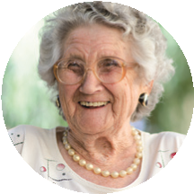
We offer friendly, professional

care in your own surroundings
All our staff are fully COVID vaccinated
We are a local Fiveways family run company
We can help with
Washing and dressing
Making meals
Cleaning and shopping
Taking you out to an appointment

or out for the afternoon
▼
▼
▼
▼
01273 542200
www.hallifaxcare.co.uk
info@hallifaxcare.co.uk

