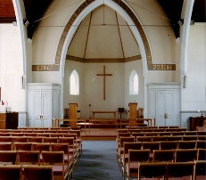
THE AVENUE
STANFORD AVENUE
METHODIST CHURCH,
BRIGHTON
June – July 2021
Minimum Donation 50p

Help Me To Be An Encouragement To Others

Lord, help me to be an encouragement to others in the same way that You have sent many little encouragements to me along the way. There have been times of weariness and times of fear and times when I have felt ready to give up, but always at the right time there was a short note or a simple call or a little token of Your love for me, which You sent by means of the many people that You have lovingly placed in my life.

Thank You also Lord, that You are our God of encouragement, and that we have Your indwelling Holy Spirit to help and to comfort in times of need. Teach me Your way and Your will, and help me to always heed the gentle promptings of the Spirit of Comfort within my heart, so that I may not miss an opportunity to be a minister of Your encouragement to others in times of need.

Oh Lord, more and more I long to breathe You into my very being and be saturated with Your love and grace, so that I may be equipped to breathe out Your love and joy and help and support and encouragement to all with whom I come in contact.

Show me Lord, how I can best be an encouragement to others, and may life point others to You and never to myself. May I decrease as You increase more and more in my life.
I pray in Jesus' name,

Amen.

THE AVENUE
Minister: Revd Dan Woodhouse Tel: 01273 508704
E-mail: revdanwoodhouse@gmail.com
Church Office Answer Phone: Tel: 01273 554141
E-mail: stanfordmethodist@btconnect.com
Assistant to Minister: Major Connie Croly: Tel: 01273 875376
Editor: Martyn Coblenz: Tel: 01273 556366
A Letter from our Superintendent Minister

Dear friends,
The story is told of an old monastery. It had once been a thriving place where many dedicated monks lived and worked and had great influence on the realm. But now only five monks lived there, and they were all over seventy. And visitors to the monastery, which was situated in a beautiful forest, were getting less each year. Clearly, they were near closure.
Close by the monastery lived a hermit who many thought was a prophet and as the monks were agonizing over what to do, they decided to go and see the hermit to see if he might have some advice for them. The hermit could only commiserate with them about their situation and when pushed by the Abbot he said “I don’t know how your monastery can be saved. The only thing I can tell you is that one of you is an Apostle of God.”
Disappointed and confused by the hermit’s reply they returned to the monastery wondering what the hermit might have meant by what he said. “One of us an Apostle of God,” they mused. “That’s impossible. We are all too old. We are too insignificant. But on the other hand, what if it’s true? And if it is true then which one of us is it?”
As they pondered on it together and individually, thinking about each other’s faults and merits they began to treat each other with extraordinary respect on the off chance that one of them might actually be an Apostle of God. And on the off chance that they themselves might be the one the hermit spoke of; each monk began to treat himself with that same respect.
As the months went by, still no closer to knowing which of them was the Apostle, the number of visitors to the monastery began to increase, many of the visitors coming back more frequently to picnic and play and sometimes to visit the chapel. It was as if they could sense this new aura of the extraordinary respect that had begun to surround the monks as it radiated out from them permeating the atmosphere of the whole place. And the visitors began to bring their friends and they brought their friends.
As time progressed and more visitors came the monks found themselves in more conversations with them and after a while one young man asked if he could join them. Then another. And another. And the community grew and once again it became a vibrant centre of light and spirituality.
And surely this is what lies at the foundation of Jesus’s teaching in passages such as Matthew 25: 31 – 46 where he talks about how we treat others. If we read that teaching in the narrative of fall and redemption, then we read it as a story of judgement and end times. But it’s real meaning is in what Jesus is revealing about God and God’s ways. And that is about living in the here and now, living life fully in God’s ways.
And the best way to do that is by treating each and every person, and that includes ourselves, with the most extraordinary respect. Treating each and every person, including ourselves, as people incarnated with the Christ. And that includes all people, whether they profess faith or if they don’t believe. It includes the good, the bad and all those in the middle. It includes those we know and those who are strangers. And that kind of respect is radical and transformative.
It was too radical for those in authority when Jesus walked this earth. The stories he told and the radical respect and hospitality he showed to all was too much for some and they tried to extinguish it by killing him. But the Christ lives on, and the Christ lives on in you and me. And the way Jesus showed is still too radical for those who believe that they who shout loudest and they who have seized power deserve the bigger share.
But like those monks we don’t always let the Christ shine through in our lives fully. We try and we do see glimpses of it in people and acts of kindness and wisdom in people of all faiths and none. We see it maybe more clearly in people like Mother Theresa, the Dalai Lama, Gandhi, Nelson Mandela. But our calling as followers of the way is that we must keep trying to do so day by day.
As we begin to unlock the doors of our buildings, I pray that we might treat each other, and that means all people, and ourselves with Christlike love and so be the visible, ongoing presence of Christ in the world, I pray we might have the strength and inspiration to live lives of radical hospitality with extraordinary respect for all people and the whole of creation. I pray that our churches will become like that monastery, a vibrant centre of light and love.
With thanks to you all for all you do,
Andy

LIFE AS A REDCOAT.

Part 2 of - LIFE AS A REDCOAT

People’s Reactions!!

I had many different reactions, mostly surprise, but one I remember very vividly.
I had been the speaker at the Women’s Own in the Wesley Hall in the old Dorset Gardens Church. There were about 100 people there, and I’d given them a really deep devotional afternoon. I then told them they wouldn’t see me for 7 months as I was going to SKEGNESS to be a Butlin’s Redcoat. To say they were stunned would be an understatement! One lady in the front row threw up her arms and said very loudly, “But I thought you were a Christian”. I think she was very relieved when 8 months later I shared some of my experiences at the same meeting. I told them that it wasn’t always easy with the rest of the Redcoats, especially where ‘drinks’ were involved. Some of them tried so hard to make me “ have a proper drink” when I had my usual orange juice. We laughed a lot together as well as shared deep conversations regarding God and religion, Some of the guys used to get so drunk and the next day couldn’t always remember much. I used to, with a laugh, tell them I’d enjoyed myself and remembered everything.

It was an amazing time and, as I said, that lady who had taken me to task before I went was very supportive when I set off to Butlin’s at Bognor the next year. And what a year that was – very different!!
More in the next magazine!!

Thanks Wynn it sounds like you had a great time at Butlin’s.

Dear Stanford Avenue friends,
As most of you know, we are now living in Melbourne, Australia, and we've been here for two and a half years now. Sadly, since we arrived, Barry's neuro-degenerative illness (PSP) has progressed quite rapidly. He had a very bad fall last July and, after a long stay in hospital and rehabilitation, he moved into permanent care in October 2020, as I was no longer able to look after him at home. We spent most of our winter in lockdown, for 112 days from June until the end of October, so we were limited to our choice of care homes, as most weren't taking new residents. Fortunately, the one we did choose is very good, with caring staff and beautiful gardens.
As for me, I have just purchased an apartment - in Brighton! Everyone thinks it's very amusing that we moved from Brighton UK to Brighton Australia. Apart from sharing a name, they are quite different, although they are both near to the coast and Brighton beach here has beach huts, which are called bathing boxes
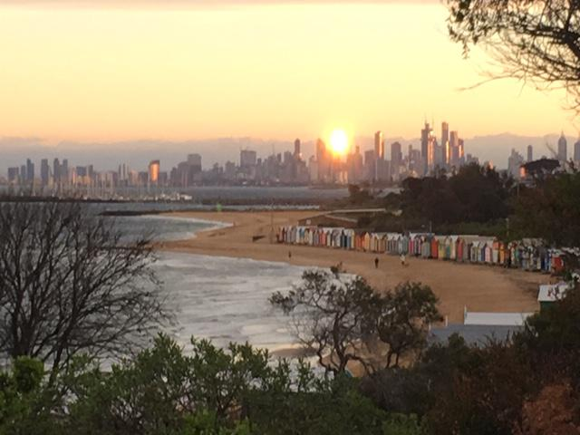
Here’s a photo I took of Brighton beach early one morning, with the cityscape of Melbourne in the background.
I’m relieved to have finally purchased a property, as house prices have increased considerably since the beginning of this year as demand exceeds supply. Interest rates are also very low, so the cost of borrowing is cheap. The conveyancing process is very different here, with property mainly sold at auction, because higher prices are usually achieved that way. Fortunately, I bought my apartment through a private sale, which is unusual, but less scary and stressful! Once an offer has been accepted by the vendor, it is legally binding, you pay a deposit of 10 or 20% and you agree a settlement date, which is either 30/60/90 or 120 days. Mine is 30 days and that’s when I pay the balance due. I am planning to move in early June, when my tenancy agreement for the house I am renting in Beaumaris will end.
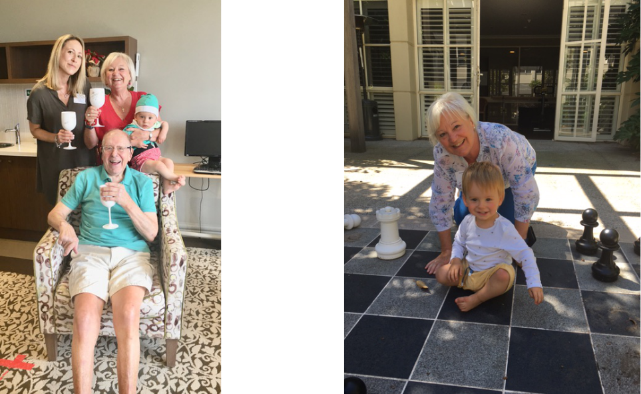
I’m sure a lot of you will remember Claire, our daughter - she is the reason we are here! She married Aaron in 2017. He is Australian and he grew up in Doncaster East, another suburb of Melbourne. They met at work, in the city of Melbourne, they live in St Kilda, which is about a 10-minute drive from Brighton, and they have a little boy Charlie, who is 18 months old - he is gorgeous, but then I am biased! I look after him every Wednesday (Grandma Day) and we get up to all sorts of fun and mischief! Claire is expecting another baby in September, so we are all very excited about that.

Claire, Barry, Me & Charlie on Christmas morning/Charlie teaching me to play chess!
I work part-time as a Medical Receptionist at Beaumaris Medical Centre, which I enjoy very much. There is no NHS here, so most people attend private clinics for their medical consultations and medication. The health system is called Medicare and you have a card, which allows you to get a rebate from the Government on the cost of your visit. There is no standard prescription fee, so you pay for the cost of the individual medication, which can be very expensive. I miss the wonderful NHS!
We started clinics for the covid vaccinations at the end of March, mainly on Sundays, and we have a quota of 400 vaccines per week. It’s a lot of extra work for us, but in general the community are grateful to be getting the vaccinations done. As I write, there is some controversy about the AstraZeneca vaccine for under 50s, but we won’t be doing that phase for some time. We are currently doing phase 1b, for over 70s. To be honest, the vaccine roll out has been quite slow, in comparison to the UK, which I know has been fantastic. I am fortunate to work in a medical centre and I had my AstraZeneca vaccination on 28th March, with no side effects at all. I’ll get my second dose on 20th June. Barry will get his first Pfizer dose in the care home on10th May.
I have been attending St Peter’s Church, Brighton Beach, since we moved here, and I’ve made a lot of friends there. We had online services during our lockdown, but Church reopened in late November, just in time for Advent then Christmas. It was so good to be back and to attend the Christmas services, even though we had to wear masks, socially distance, no singing and no communion bread or wine. We’ve very gradually almost got back to normal, and it was so lovely to attend the Easter Sunday service last Sunday morning. The church looked so beautiful, filled with flowers, the congregation wearing colourful clothes and the happy, smiling faces of the choir and our vicar, Reverend Jonathan. A wonderful sight to see and very uplifting. I hope you will soon be back worshipping in church, with your church family, at Stanford Avenue.

St Peter’s Church, Brighton Beach
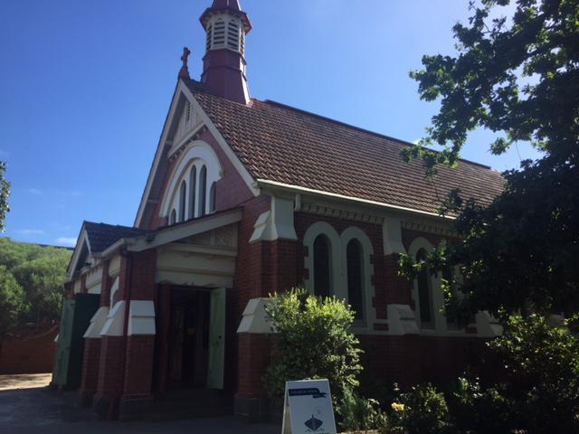

Sending our love across the miles. God bless you all.

Carol Hocken X
WHO SAID THESE FAMOUS SAYINGS?

- “An eye for an eye only ends up making the whole world blind”.

- “I have a dream”.

- “A rose by any other name would smell sweet”.

- “Tis better to have loved and lost than never to have loved at all”.

- “It was the best of times; it was the worst of times”.

- “I still believe, in spite of everything, that people are truly good at heart”.

- “I came, I saw, I conquered”.

- “I learned that courage was not the absence of fear, but the triumph over it”.

- “Life is what happens when you are busy making other plans”.

- “Call me Ishmael”.

Answers on last page.

CHURCH FAMILY NEWS

We continue to pray for June & Bob Lawson,
Joan Dengate, Nadine & Gary Pugh, Ann Collins,
Vic Pollard, Sylvia Smith, Debbie, Jean Griffin, Abbi,
Liz Wakeling & Amy Codling (Leaders of Scouts & Girls’ Brigade), Phil Codling, Maureen Knell, Sheila Whyte, Syd Beck, Jean & Geoff Starks, Shirley, and Gill & Shirley Challen, John & Karen Patching on their recent loss.

As always, please let me know if you want me to remove any names, add to them or update us with news of any of the above.

We, of course continue to pray for our Circuit staff as they minister to us – namely – Revd’s Andy Lowe, Deborah Cornish, Dan Woodhouse, Heather Leake Date, Major Connie Croly, Sue Harrington, and all our Lay Workers and Local Preachers.

ALAN CODLING

I have received the following tributes from Amy Codling from the funeral of Alan.

The family and I wish to thank everyone for all your kind words, thoughts, love and prayers over the last few weeks. With the current restrictions we were only allowed a few people at Alan’s funeral, but modern technology enabled many to watch the service online. We have received many comments following this and it has all been very overwhelming.

From Ian

My dad, Grandpops to Gareth, Louisa, Charles and Lillian, my children.
Dad was born on 29th April 1946 in Brighton, son of Vera and William.
His older brother Tony who cannot be with us today has shared some words with me to share with you.
We three brothers enjoyed many hours of childhood with our model railway layout using all available pocket money as we grew up in Whippingham Road, Brighton. Camping holidays were all the better for enjoyable companionship too. Then we all went our separate ways.
Alan will be sadly missed by his brother Tony, and his wife Wendy, who enjoyed recent holidays with Alan and Amy, and regularly met up for lunches and a nice chat.
Thankyou Tony.

Dad met Mum through St John in 1966 and after Dad proposed to her in 1967, they were married in 1971.
Three sons were brought into the family – Phillip, myself and Matthew.
Dad first worked up at Brighton General Hospital and later took a job at Hove Borough Council working in the Rates Office and onto the Benefits Office where he eventually became the assistant manager retiring in 1997 after 27 years’ service.
As I grew up dad shared his love of model railways with me. It was fun playing with the trains on a large base board that used to live behind the chest freezer. I still need to find the space to set up my Hornby set properly! One day.
Dad was the source of tools and DIY knowledge and even helped me to landscape the garden in my first house, building steps and walls with me. If I needed to do something, he would let me know the best way to do it.
After retirement Dad was always active, at St John, helping on first aid courses, and working at the counts for local and national elections. He and mum spent many short breaks away together over recent years until Dad became unwell.
Unfortunately, cancer took control and after many spells in hospital, he came home to be with mum. He was able to spend his last weeks with mum, where he wanted to be. He passed away just short of their 50th Wedding anniversary.
I, we, will miss you dad, grandpops. Rest easy now, all the pain has gone. Love you.

The following is also from the funeral on behalf of St Johns Ambulance.

Matthew and his family asked me to stand up today, to say a few words about our friend Alan, speaking on behalf of St John Ambulance, an organisation he dedicated most of his life to.

Lifelong volunteers like Alan, touch so many lives over the years that they serve, I can’t possibly hope to sum up everything people would want me to say. But of course, it’s an honour to be given the chance to talk about Alan and to tell you how much he meant to the St John family, especially here in Brighton.

Alan joined St John Ambulance as a Cadet in Brighton, on the 20th November 1958. His service in almost 65 years since, has been selfless and exemplary. It also led to him meeting his wife Amy, who has continued to support the St John family herself, throughout their long marriage.
He rose to the lofty heights of cadet Corporal and then Cadet Sergeant, before transferring to the Adult Unit as a brigade member in 1962. He took on custody of the Ambulance as Transport Sergeant in 1982 and was part of a team that made Brighton a more integrated part of the Sussex team, regularly attending duties to help other units, and inviting others to support Brighton too. It was around this time he took on the treasurer responsibilities. He was appointed Divisional Officer in 1990 and Superintendent in 1991.

Alan was appointed as the Vice President in 1998 and President in 2003. He was an Active Unit President across Badger, Cadet and Adult units until his passing. Truly a lifetime of dedication.

I’ve spoken to many people about Alan’s work over the last couple of weeks since I knew I would be standing here today. Everyone throws in something else that he did. From marching in the Brighton Band, teaching first aid in front of the Palace Pier back in the 60’s, marshalling at Operation Moonshine, to training and of course, attending countless events as a first aider including carnivals, motocross, horse driving trials, and as one person recalled, an NTC Founders Day at Withdean Stadium where it was so hot and busy, Alan was seen carrying fainted patients one by one from the parade ground to the treatment centre as the team had run out of stretchers.

Alan was a keen fundraiser, organising flag days and collections across the city and of course, he was a big part of the team that raised the funds for Brighton’s first Crusader Ambulance, which escorted him here today.

Alan was always happy to help out across all sections of the unit, always making himself available for Cadet and Badger meeting nights, regularly training and taking part in the games being played. He would also visit other youth groups to deliver first aid training. As a trainer for the organisation, as well as a regular patient for exams, he was able to convince many people to expand their FAW training by joining the unit. He’s responsible for a many peoples first entry to the organisation.

He was proud to greet the Mayor of Brighton on big St John occasions, most recently for the Brighton Centenary celebrations a few years ago and he even got to attend a Palace Garden Party too. And of course, he was pivotal in moving Brighton from the HQ at the racecourse to the current building in Hollingbury, and it pre dates me, but I strongly suspect he had no small part to play in moving them in the race course in the first place!

As a unit president, he was uniquely hands on. Not one to just turn up for an awards evening or a VIP visit, almost everyone I spoke to shared the same memory of Alan as the one I will always hold myself, that of him, sat in the back office, preparing equipment to make sure everything was ready for a duty or training night. As one person said to me – ‘You always knew where to find Alan on a Tuesday night!’ Whether that was cleaning the resus Annie’s, making up training packs or getting first aid kits prepared for the next weekend’s duties, Alan was always hands on, quietly working hard in the background, to make sure members had what they needed. Only recently the Badger Leader mentioned to Alan that she thought it was a shame there was no First Aid kit for Badgers who had just passed their first aid badge. Before she knew it, Alan came good, putting together small kits to present to each newly qualified Badger.

Alan was recognised by St John for his outstanding commitment, above and beyond what would be expected of a volunteer, by his admission to The Order of St John, first as a Serving Brother, and more recently, being promoted to an Officer in The Order. Most people won’t know that St John Ambulance is part of an ancient Order of Chivalry – dating back 1000 years, the Order is headed by HM The Queen and is part of the UK Honours & Awards system. The appointment as an Officer of The Most Venerable Order of St John of Jerusalem, to give it it’s full title, is an honour reserved for the hardest working volunteers, and is personally sanctioned by The Queen. It’s something that I know he was rightly, incredibly proud of, as were we all.

In fact, in his illness and his passing, he’s achieved two St John firsts. At Christmas, Alan was the first ever recipient of the awarding of his Officer of the Order medal via a Zoom meeting. And a couple of weeks ago, we took delivery of his Gold Long Service medal, delayed in presentation because of Covid. The only official presentation of this brand-new Gold Medal that I’m aware of, was made early last year to Her Majesty The Queen. Both of those medals adorn his coffin today. I know in particular, that when HM’s Lord Lieutenant for Sussex, Sir Peter Field, knocked on Alan and Amy’s door after the virtual presentation, to present his medal physically, it was an extremely proud moment for him. As was receiving his Gold Medal certificate a short while ago, and Amy tells me he was quick to show off both to all the carers that visited the house in his last few weeks.

Covid of course means, that it’s been hard for people to join us here today. But the love and kindness I’ve seen from Alan’s St John family this last couple of weeks, has really shown the measure of the man. Calm, reassuring, caring. Not seeking the praise or the limelight. Happy to be in that back room, happy to be the one cleaning out the kit, doing the work others didn’t always even know needed doing. A gentleman, and a St Johnner through and through.

God bless you, Alan. We will miss you hugely, you leave a massive gap in the Brighton St John family. Your legend lives on in the successful, bright, busy and modern Brighton unit that you leave behind.

Your duty is now over, but your memory lives on.

As most of you know Phil Codling (One of Amy’s Sons) has been in hospital for a very long time. He has sent this via the Church email).

I can’t believe that I have been here for 81 days.
I was transferred to a general ward this week after so long in ITU and now it’s rehab time! All the and tracheotomy removed leaving me with just a little ongoing oxygen support.
I’m so grateful to the amazing staff in ITU for looking after me when I was so sick.
I now have to learn how to do absolutely everything from using a knife and fork to walking. It’s very frustrating when you know what to do but your body hasn’t got any strength to do it!!
So far, I have managed to re-master using my phone to send texts/email (very slowly), brushing my teeth and use a spoon or fork without pouring the food over me. I still have more work to do with my left arm as it’s much weaker than my right arm.
We’re also working on the bigger things like standing and eventually walking and this is really hard. As you can see in the photo, this was the first time I managed to stand up with a lot of help from the physios and the frame. That was really painful using muscles not used for 3 months.
There’s a long way to go before I’ll be able to get home but thanks for your thoughts and prayers over these months and I will keep you posted on how things are going.

DID YOU KNOW.

Did you know that the letter Q does not appear in any U.S. state name?

Did you know Viking men wore makeup.

Did you know Winston Churchill was hit by a car and nearly killed during a New York visit?

Did you know “strengths” is the longest word in the English language with one vowel?

Did you know actor Daniel Radcliffe went through nearly 70 wands and 160 pairs of glasses during the making of the Harry Potter films?

Did you know Loch Ness contains more freshwater than all of England’s lakes combined?

Did you know Shakespeare invented more than 1,700 words?

A sneeze travels about 100 miles per hour.

Earth has travelled more than 5,000 miles in the past 5 minutes.

To produce a single pound of honey, a single bee would have to visit 2 million flowers.
Contributions Needed.
In the last issue I asked for contributions to be included in our Magazine. Wynn tells of her life as a Redcoat, and I have received items from Ivor Challis and Gill Challen. I’m sure that someone has some interesting hobbies, stories etc that would give pleasure to our many readers. Please do send them in. Remember this is your magazine.
Please send them to the stanfordmethodist@btconnect.com or dropping them through the Church letterbox.
Martyn.
LAST DAY for AUGUST – SEPTEMBER 2021 magazine contributions will be FRIDAY 23rd JULY.

You will be able to send contributions via E-Mail: stanfordmethodist@btconnect.com, or, by post to Stanford Avenue Church with ‘For Magazine’ on the front of the envelope.

PAUSE FOR THOUGHT
I’m not sure how to begin this Pause for Thought, Yes, I Do!
Thank you for the many cards I’ve received since being diagnosed with breast cancer. It has reminded me of the 300 plus cards and letters I received after my RTA 3/12/96. I still have them ! Gwen Beckerlegge wrote to me every week of my 3 months stay in hospital. I knew everything that was going on at The Avenue! The majority of them assured me that the senders were praying for me, and most of the ones I’m receiving now say the same. Now as back in 1996/1997 I feel comforted and strengthened.
By the time you read this I will be recovering from an operation on 1st June at Haywards Heath. That will be just 9 weeks after I saw my doctor who set the ball rolling, most impressive. He’s been a real eye opener too !
I’ve often driven past the Breast Centre, London Road opposite Preston Park but had no knowledge of the amazing work done there. They are so busy but give you the impression they are just for you. There are 4 surgeons – many nurses, 4 MacMillan Nurses, and admin staff. I was talking to someone treated there 15 years ago, her husband is attending there for Radio Therapy. They too assured me of their prayers.
In a book of Daily Devotions Guide there was a section called THE POWER OF PRAYER. There was a reading written by a man in NEW JERSEY that went “Sometime ago, when I was recovering from a heart attack, several of my friends wrote in cards they sent to me that they were praying for me. What an inspiration that message gave me. They did not say, I’m thinking of you – they said I’m praying for you” Prayer is a powerful thing. Jesus was a man of prayer.
Often, we see him praying with other – as He lead – preached – taught. He prayed alone – on the Cross, for those who had nailed him there.
In Acts 2: 43 – 47 we get a glimpse of those early Christians.
“ALL THE BELIEVERS CONTINUED TOGETHER IN CLOSE FELLOWSHIP AND SHARED THEIR BELONGINGS WITH ONE ANOTHER. DAY AFTER DAY THEY MET AS A GROUP IN THE TEMPLE AND HAD THEIR MEALS TOGETHER IN THEIR HOMES EATING WITH GLAD AND HUMBLE HEARTS, PRAISING GOD”.
We can picture them praying. As I said, PRAYER IS A POWERFUL THING. He knows what we have need of.
There are 2 lines from the hymn Great is Thy Faithfulness that have come to mind, STRENGTH FOR TODAY, AND BRIGHT HOPE FOR TOMORROW. So let us keep praying for each other and the NHS Workers.
LOVE WYNN.
Martyn - Thanks Wynn.
QUIZ TIME ANSWERS.

Mahatma Gandhi, Martin Luther King Jr, William Shakespeare (Romeo & Juliet), Lord Tennyson, Charles Dickens (Tale of Two Cities), Ann Frank, Julius Caesar, Nelson Mandela, John Lennon, Herman Melville

advert
h b c
For bathrooms

195 Church Road,
Hove BN3 2AB
Tel: 01273 730149
Fax: 01273 207438

For top quality bathrooms & showers, retail only or full design & installation
(family business)
Directors: Michael Bellis, Marilyn Bellis & James Houldcroft

ACTION ROOFING SERVICES LTD.
Specialists in all types of Roof Renewals & Repairs
Tiling – Slating – Felting/Asphalting
Free Estimates
12,Plainfields Avenue
Brighton BN1 8RJ
Telephone: 01273 555535
www.actionroofingservices.co.uk
K. H. Tahsin

Retired decorator looking for a bit more work
01273 419914

Hallifax Care
h
c
Friendly, professional care in your own surroundings

All your care needs provided by a local Fiveways independent company

we can help with:
- washing and dressing
- making meals
- cleaning and shopping
- taking you out to an appointment
or out for the afternoon

01273 542200
www.hallifaxcare.co.uk
info@hallifaxcare.co.uk

